SPARK: Simple Play Adaptations to Reference for Kids

Giant Alphabet Stampers Set – Upper Case
Description: | Image:
The stamps are labeled for quick identification. Each 3" diameter letter stamp features an easy grip handle, with see-thru top for easy placement. The color-coded handles also make sorting and storage of the stamps easy. Stamps can be used with a stamp pad or paint. Set includes 26 letters and 2 punctuation marks. | 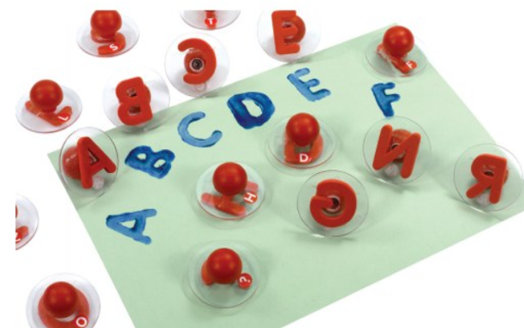  Purchasing Information

Who Might Benefit?
Those who…
• Have difficulty holding writing tools.
• Experience motor challenges that interfere with combining strokes to form letters.
• Express a desire to “write”.
• Enjoy or respond to sensory experiences.
Provides an opportunity to…
• Form lower case letters by stamping them with ink or paint.
• Practice “writing” letters, numbers, and words.
• Engage in art activities which may include a discussion about letters.
Instructions for Use: | Adaptation Ideas:
Environmental Considerations  - Consider a designated area for stamping with ink or paint which might include an easy to clean mat or a cookie sheet.  - Avoid carpeted areas when using ink pads and/or paint.  - Warning: Choking Hazard - Small Parts. Not for children under 3 years.  Positioning  - These stamps can be used in a variety of positions, however it is important that the user(s) are able to view them and reach them easily.  - Stamping activities work best when paper is secured on a solid, flat surface (ex. tabletop, floor, tray, easel, wall)  Alternate Positioning  - Tape paper being stamped on a vertical plane (easel, wall, bulletin board, filing cabinet) for children who may have difficulty seeing materials on a tabletop.  Basic Play/Use  - Provide ink pads or paint, paper, and stamps without specific directions, allow children to create, then talk about what they stamped and why.  - Stamps can be used to “start” a drawing or art project, then encourage the child to add additional details with markers, crayons, yarn, etc.  Extended Play/Use  - Provide laminated cards with letter sequences, words, or the child's name so they can practice locating the letters and stamping them in order to match what is printed on the card(s).  - Match letter stamps to an alphabet strip.  Play/Use with Others  - Pair children and show them how to form a Tic Tac Toe Grid on paper. Encourage them to choose a letter to play.  - Read the Story Chicka-Chicka Boom Boom and stamp the letters as they are read or incorporate the letter stamps into a theme-related art project. | Optional Additional Materials/Supplies  - Dycem, shelf liner, or Velcro  - Wikki Stix or rubber bands  - Shallow rimmed tray (e.g. cookie sheet  Build It Up  - Build up stamp handles with Wikki Stix or rubber bands.  Stabilize It  - Stabilize ink pads or paint containers with Dycem, shelf liner or Velcro so they do no not slide when the child is pressing the stamp onto the inkpad or into the paint.  - Tape down paper that the child is stamping or clamp it onto an easel.  Simplify It  - Offer only a few letters at a time, perhaps starting with letters of the child's name.  Contain It  - Place paper, paint, ink pads and stamps on a rimmed cookie sheet or box lid so that the area to be stamped is defined and contained.  Add Sensory Cues  - Add textures to the handles of the stamps for additional sensory information.  - Provide other substances to use with stamps such as damp sand or shaving cream colored with food coloring.  - Create circular stencils slightly larger than the circumference of the stamping surface and highlight the opening so a child with low vision or a tendency to stroke with the stamp can "aim" for the hole.  Communication Support  - Provide a paper-based communication board with alphabet letters and activity related words such as help, more, finished, stop, go, etc.  DIY Alternatives  - During outdoor play use stamp with water on a painted surface and watch the letters “disappear” as the water marks evaporate.

Resources:
- Explore the Chicka Chicka Boom Boom Shared Reading Kit from the OCALI Lending Library

Ohio Early Learning Standards:
- LL: Print Awareness: Develops knowledge of the alphabet (3 b.).
- CR: Artistic Engagement and Expression: Expresses ideas and feelings through visual art (1.a.).
- PW: Motor Development: Demonstrates developing control of fundamental fine motor skills, including hand-eye coordination (1.b.).

Words to Encourage Play/Use
Pick  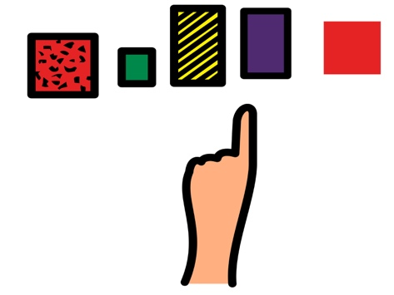 | Find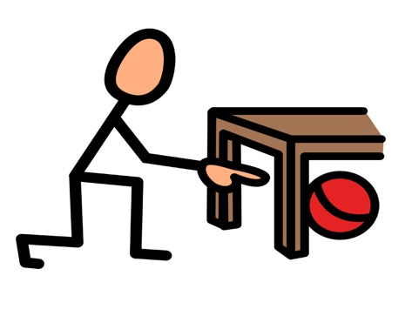 | Push 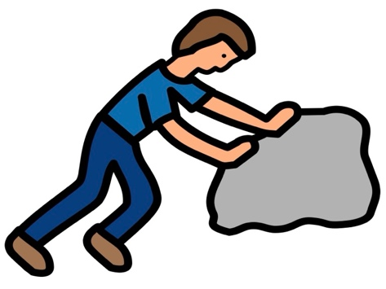
Hold | Ready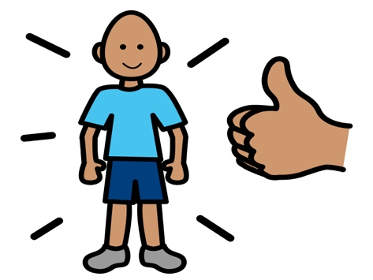 | Help 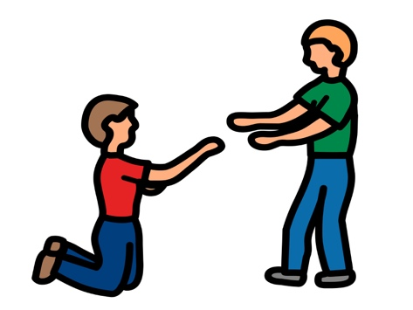
More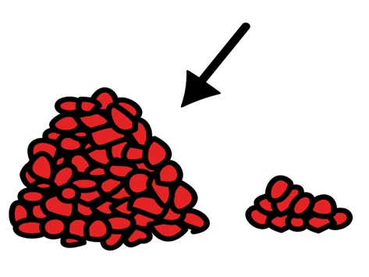 | Done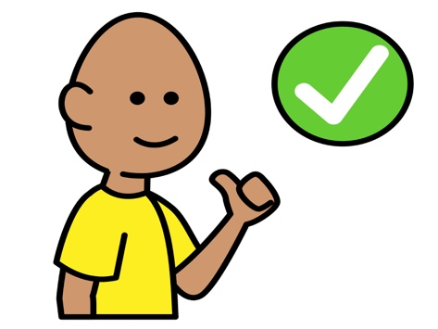 | Share  
*”Adaptations” adapted from: Haugen’s Modes for Adapting Toys based on materials from the "Let's Play" Project at the University of Buffalo
PCS is a trademark of Tobii Dynavox, LLC. All rights reserved. Used with permission.

